**ONGAS COMPACT 24-28 KW**

### USER’S MANUAL

**DOMESTIC CONDENSING BOILER**

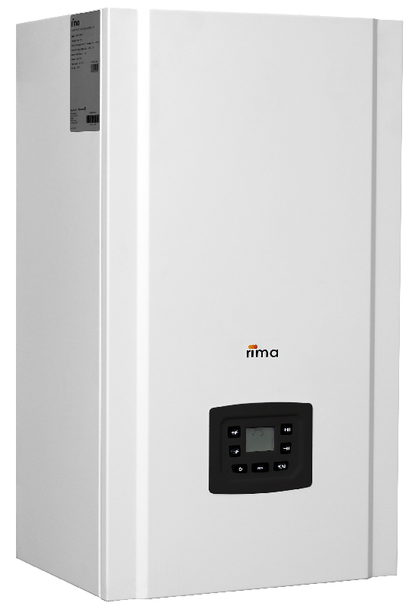



**TABLE OF CONTENTS**

1. General Information 4

1.1 Introduction 4

1.2 Certificates 4

1.3 Explanations of the Symbols 5

1.4 General Warnings and Recommendations 5

1.4.1 Points to be Considered During Handling and Transport 6

1.5 Power Saving 6

1.6 Safety Instructions 7

1.7 Responsibilities 7

1.7.1 Things To Do Before Calling an Authorized Service 8

1.8 Explanation of the Symbols on the Packaging 10

1.8.1 Parts Delivered With the Product 10

1.9 Labels 11

1.9.1 Gas Type Label 11

1.9.2 Data Label 11

2. General Specifications of the Condensing Boiler 12

2.1 General View of the Components of the Boiler 14

2.2 Technical Specifications of the Boiler 15

3. Installation and Commissioning 16

3.1 Packaging and Handling 17

3.2 Dimensions of the Boiler 18

3.3 Gas Connections 19

3.4 Electrical Connections 20

3.5 Electrical Wiring Diagram 21

3.6 Starting up and closing the boiler 23

4. Operation of the Boiler 24

4.1. Control Panel Display 24

4.2. Mode of Operation 24

4.2.1 OFF Mode 28

4.2.2 STAND-BY Mode 30

4.2.3Setting CH Supply Temperature 32

4.2.4Setting DHW Temperature 32

4.2.5Burner Ignition 32

4.2.6CH Mode 32

4.2.7DHW Mode 32

4.3Protection and Error Conditions 32

4.3.1Lockout Conditions 32

4.3.2Blocking Conditions 32

4.4Room Thermostats 32

5. Installation and Inspection of the Piping 34

5.1 Heating (Radiator) Water 34

5.2 Condensation Water Drain 37

5.3 Instructions for the Adjustment of Gas Ratio 37

5.3.1 Gas Leak Test 37

5.3.2 Adjustment of Gas Rate 37

5.4 Flue Connections 39

6. Cleaning and Maintenance 49

6.1 Inspection of the Burning System 50

6.2 Cleaning of the Modulated Fan, Venturi, Burner 50

6.3 Cleaning of the Siphon 37

7. Warranty Conditions and Commissioning 51

1. **GENERAL INFORMATION**

**1.1** **Introduction**

First of all, we would like to thank you for choosing the RIMA brand.

In this manual, you will find installation and operation information for the RIMA branded domestic gas condensing heating boilers with aluminum cast fins manufactured by ÖNMETAL.

Please read this booklet carefully in order to operate your device with high efficiency and economically, comfortably and for a long period.

DO NOT tamper with any component or setting of your device for any reason other than as described in this manual, such as operating, adjusting, or maintaining the device.

Have your device installed by Authorized Dealers.

Our Authorized Dealers and After-sales Service Centers shall provide you with the necessary information about the operation and maintenance of your device after placing the device, making the required connections and commissioning it.

In case you cannot contact with our Authorized Services and for any problems you have, our Central Technical Service shall help you.

We wish you to use your boiler in good times.

**1.2 Certificates**

Önmetal Döküm Sanayi AŞ. is certified with the Certificate of Competency with After-sales Services as per TS 12676 Authorized Services - The Rules for the Boilers and Heat Exchangers as the scope of the service dated and numbered 14.09.2011/0 and issued by the T.R. MINISTRY OF CUSTOMS AND TRADE’s Directorate General of Consumer Protection And Market Surveillance, and with the Service Place Competency Certificate issued by TSE.

The structure and operation of the boilers comply with the Regulations of European Union and the conditions stipulated in the regulations of all countries in which the European Union Standard is applicable.

ONGAS Compact 24-28 kW Domestic Condensing Boilers are the registered brands of Önmetal Döküm Sanayi A.Ş. and they are manufactured in the own facilities of the company in Edirne, Turkey.

* EN 15502-1+A1:2022
* EN 15502-2-1+A1:2017
* 2016/426/EU – Gas Appliances Regulation
* 2014/35/EU – Low Voltage Directive
* 2014/30/EU – Electromagnetic Compatibility Directive
* 92/42/EEC – Efficiency Directive
* 813/2013/EU – Ecodesign Regulation
* 2009/125/EC – Ecodesign Requirements Directive (implementing directive)

RIMA ONGAS Compact 24-28 kW Domestic Condensing Boilers comply with the **EC Directives**.

**C:\Users\Fadime Cakmak\AppData\Local\Microsoft\Windows\INetCache\Content.Outlook\GEI3KHZW\ikaz işareti.jpg1.3 Explanations of the Symbols**

Warning Signs



Safety Warnings are indicated with a warning triangle.

Important information for the safety of persons are indicated with the symbol on the left

**1.4 General Warnings and Recommendations**

C:\Users\Fadime Cakmak\AppData\Local\Microsoft\Windows\INetCache\Content.Outlook\GEI3KHZW\ikaz işareti.jpg• ONGAS Compact 24-28 kW Domestic Condensing Boilers with Aluminum Cast Fins are designed to be used in heating installations with hot water and/or in hot water installations and manufactured with the technology and materials suitable for this design.

• Capacity selection of the boiler shall be performed according to the installation projects prepared in accordance with the standards. Otherwise it may not be possible to obtain the desired efficiency from the boiler.

• If the boiler has stopped automatically due to over-temperature, do not add cold water to the boiler to restart the boiler. Wait until the boiler has cooled down and then try restarting, if it does not, inform the authorized service.

• Electrical supply of the boiler is provided from the mains. Mains supplied electrical equipment is obligated to connect earth. For this reason, power and lighting installation, electrical connections of the boiler, grounding line shall be made by experts of their field in accordance with the relevant standards

• All electrical and electronic controls are supported on the control panel located at the inside of the boiler.

**• The cleaning of the installation is of utmost importance for the transformation projects from boilers with solid fuel or liquid fuel to boilers with gas fuel. The installation shall be washed, any leaks shall be detected and repaired.**

• Boilers shall be installed in a place with no risk of frost. When the boiler is not operated, the water remaining in the radiators shall be drained to prevent freezing.

• Boilers shall not be installed in a location that contains moisture, vapor or dust. Otherwise the boiler shall not operate correctly and efficiently.

• The supply of fresh air shall be free of halogen hydrocarbons (sprays, paints and some chemicals), otherwise these shall cause corrosion and erosion of the boiler and flue.

• Flammable materials shall not be placed on or near the boiler.

• Fresh air intake shall comply with the instructions of the local gas supplier and the instructions for gas connection, otherwise there is a risk of poisoning.

• Condensate and flue connections shall be made in accordance with the rules and standards.

• Before starting to work on the boiler, always disconnect the main power line and turn off the main gas valve.

• Boiler cannot be operated by children less than 8 years and mentally handicapped.

• If you smell gas, turn off the main gas valve and call the emergency number for gas leaks in your neighbourhood. If you smell flue gas, turn off the boiler and call the authorized service immediately.

|  |  |
| --- | --- |
| Combustibility (flammability) levels of construction materials and products | |
| A- Non-combustible | Granite, sandstone, concrete, brick, ceramic, fireproof plasters |
| B- Very Difficult to Burn | acumin, isumin, heraclith, lignose, fiberglass components |
| C1- Difficult to Burn | Products made of beech or oak, hobrex plates, werzalit, umuakart |
| C2- Medium Combustibility | Wet wood, black pine, cork and tree crumbs, rubber sole |
| C3- Easy to Burn | Asphalt Components, Fiber components, cellulose materials, polyurethane, polystyrene, PVC, polyethylene |

Keep the boilers at least 200 mm away from flammable materials with B, C1, C2 burning classes as specified in the table during their installation and operation.

• For materials that burn rapidly and by themselves after any spark, that are easily ignitable with a burning class of C3, increase the safety distance to at least 400 mm.

The boiler is set for natural gas H/E (G20, 20 mbar) in the factory.

• To prevent incorrect circulation, control valves shall be used in conjunction with the circulation pump system. A strainer (filter) shall be used in the return water lines of the new/old buildings and new/old installation systems.

• Supply of cold water to the boiler shall be performed when the boiler is cold.

• It is possible that oxygen may pass through the floor heating pipes into the water. Oxygen in the water causes corrosion of the boiler. Therefore, if the boiler is to be used in a floor heating system, a heat exchanger shall be added to the circuit and mixing of the boiler water and installation water shall be prevented.

Read the technical instructions before installation and operation.

**1.4.1 Points to be Considered During Handling and Transport**

* Products are shipped on pallets as protected by styrofoam and film.
* The products are fastened inside the box with retaining screws.
* Appropriate markings are provided on the case. During storage, it may be stored at proper ambient humidity and temperature without opening the package.

**1.5 Power Saving**

The proper use of energy resources in our world is a real problem of modern societies. While we are generating energy for our future, we use natural resources that shall be exhausted in the near future unless we encourage more rational and efficient use of these resources.  
Condensation technology is a big step towards the rational use of energy as it provides energy savings of up to 35% and lower emission values ​​(80% for CO and 90% for NOx) compared to conventional heating systems.

Moreover, the annual CO2 emission values ​​of high efficiency condensing boilers are 20% less in average than the boilers with standard efficiency.

In the countries that have advanced in technology, all of the new boiler installations are selected as condensing boilers and the governments have started to encourage persons to choose this technology.

The device offers intuitive and advanced diagnostic systems that allows detection of faults by the user.

**1.3.4. Safety Instructions**

The boiler is connected to 230V mains.

An incorrect installation or any attempts to repair using incorrect electrical components may pose a lethal risk.

C:\Users\Fadime Cakmak\AppData\Local\Microsoft\Windows\INetCache\Content.Outlook\GEI3KHZW\ikaz işareti.jpgKeep unauthorized personnel away from the boiler. Do not leave any objects on or near the boiler.

**C:\Users\Fadime Cakmak\AppData\Local\Microsoft\Windows\INetCache\Content.Outlook\GEI3KHZW\ikaz işareti.jpg**

Do not touch the hot water connections or the flue outlet during the operation of the boiler - risk of burning.

Installation, repair, commissioning and maintenance operations shall only be carried out by suitably qualified personnel. It complies with all relevant international/local standards and certificates.



Before starting to work on the boiler, always disconnect the main power line and turn off the main gas valve.

If you smell gas, turn off the main gas valve and call the emergency number for gas leaks in your neighborhood. If you smell flue gas, turn off the boiler and contact the authorized service or the installer.

**1.7 Responsibilities**

Manufacturer’s Responsibilities: They shall manufacture and ship products in accordance with the relevant directives

Responsibilities of the Contractor: Contracting company is responsible for the installation. The company shall read this manual and follow the instructions provided in the manual before calling the authorized service.

**1.7.1 Points to Consider Before Contacting the Authorized Service**

First of all, we would like to thank you for choosing and using the “Rima Condensing Boiler”. Below is a list of things to do before calling the Rima Authorized Service.

* Protect your device against factors that may damage the packaging and the device (moisture, water, impact, construction materials, etc. ) during the transport and subsequent assembly of the device. The boilers shall be installed on a stable, firm ground. In case of a surface which is not suitable for supporting of the boilers and the connection equipment, a suspension system with a metal profile shall be used.
* The installation water shall be conditioned by considering whether the system is a new heating system to be installed or an heating system to be transformed. If the installation to be used for the system is old or if it shall be transformed, the water in the installation shall be completely drained and water shall be conditioned (cleaning shall be performed and a preservative shall be used). The presence of blockages in the heating installation such as dirt, sediment, burrs, iron dust, lime, etc., adversely affect the operation of the boiler. This may cause inefficient operation, overheating, noisy operation, and damage to the heat exchanger of the boiler over time. Installation water shall be conditioned and preserved in new installations.
  + 7<pH value used in the installation> 8.5
  + For the hardness of the water, the hardness value appropriate to the capacity shall be determined in accordance with the table given below.

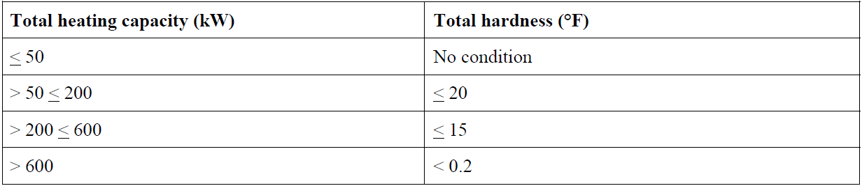

* Water containing sediment or of unknown content such as well water and transport water shall not be used. Use of any chemicals by adding them to the installation without the approval of the manufacturer shall render the products void of warranty. As Rima Heating Systems, we recommend use of water treatment products with Sentinel X100, X300 or X400 brands. Use neutral, non-acidic and non-alkaline cleaners. Any damage to the product or installation that may occur without taking the approval of the manufacturer in applications performed using the products of different companies is out of warranty cover. It is the user’s responsibility to ensure that the water to be circulated in the installation is clean.

**Pressure Loss**

|  |  |  |  |  |  |  |  |
| --- | --- | --- | --- | --- | --- | --- | --- |
| BOILER MODEL | CAPACITY (kW) | ΔT = 10 °C | | ΔT = 15 °C | | ΔT = 20 °C | |
| Water rate (m³/h) | Pressure loss (mbar) | Water rate (m³/h) | Pressure loss (mbar) | Water rate (m³/h) | Pressure loss (mbar) |
| ONGAS Compact | 24 | 2,1 | 80 | 1,4 | 60 | 1,0 | 40 |

* All electrical installations are the responsibility of the contractor. Connect your device to a 220 - 230 V single phase and grounded power supply. Connections to the boiler shall be performed by the authorized service. All connections to be made on the electrical panel through the boiler shall be performed by Rima authorized service centers. If it is desired that the electrical installation is also performed by the authorized service, labor costs shall be subject to a charge to be determined by the service.
* A certificate of conformity shall be taken from the gas companies before calling the service.
* Ongas Compact may be operated with natural gas and LPG. Gas pressure in the gas line shall be set with a regulator and a filter shall be present in the gas line.
* Any leaks in the installation shall be repaired. Faults and damages that may occur due to power-water-gas installations and/or installation equipment, leaks in the installations, installation connections, and flue connections are out of the warranty cover. Automatic supply shall not be applied.
* The systems where our gas fueled condensing boilers shall be installed are closed-circuit systems. An open expansion tank shall not be used.
* The application pressure of the system is between 0.8 bar and 3 bar.
* The boiler drainage shall be directed so that flowing of the condensation water is allowed. The materials used for the installation the condensate drainage shall be made of plastic. Blocking the condensate drain shall cause the boiler to shut down automatically or leak from the siphon. If you suspect a frost condition, it shall be useful to pour hot water into the exposed part of the drain. Always ensure that the drain is open to ensure that the boiler functions properly.
* The heating system has a protection function for conditions with a risk of frost. To enable this function, the power to the boiler room shall be switched on
* Faults and damages that occur due to the environmental conditions and incorrect storage by the consumer are not covered by the warranty.

**IMPORTANT:** If deficiencies in the system are detected by the service personnel during the commissioning, our service shall not commission the system; and the service fee incurred when the service is called again for commissioning following the provision of the necessary conditions in the system shall be borne by the user.

Responsibilities of the User: Reading the manuals, maintaining and preserving the product in accordance with the warranty conditions, and preventing the intervention of persons other than the authorized service.

**1.8 Explanation of the Symbols on the Packaging**

Fragile Top side Recycle Protect Against Water



All gas devices shall be installed by qualified technicians. Any error in the installation of these devices may result in criminal actions as required. RIMA ONGAS Compact 24-28 kW Domestic Condensing Boilers shall not be installed or modified in any way other than those specified in this manual. Always keep the boiler in its safety packaging during its transport before installation. Additional protection measures may when required by the installation site. Please follow the rules and instructions for the authorization of the installation.

**1.8.1 Parts Delivered as Standard with the Product**

* Siphon Assembly
* Operating Manual
* Warranty Certificate

Important: Operating instructions to ensure that the boiler may be used without any problem for many years are included in the operating manual.

**1.9 Labels**

**1.9.1 Gas Type Label**

|  |  |  |  |  |
| --- | --- | --- | --- | --- |
| **COUNTRY OF DESTINATION** | **GAS USED** | **SUPPLY PRESSURE (mbar)** | **PRODUCT CATEGORY** | **TYPE** |
| AT, BG, CH, CY, CZ, DK, EE, ES, FI, GB, GR, HR, IE, IT, LT, LU, LV, NO, PT, RO, SE, SI, SK, TR | G20 | 20 | I2H | C13, C33, C93 |
| DE, NL, PL, RO | G20 | 20 | I2E |
| HU | G20 | 25 | I2H |
| BE, CH, CZ, ES, FR, GB, GR, HR, IE, IT, LT, NL, PL, PT, SI, SK, TR | G31 | 37 | I3P |
| CH, CZ, ES, GB, GR, HR, IE, IT, LT, PT, RO, SI, SK, TR | G20, G31 | 20, 37 | II2H3P |

** The boiler is set for natural gas H/E (G20, 20 mbar) in the factory.**

**1.9.2 Data Label**

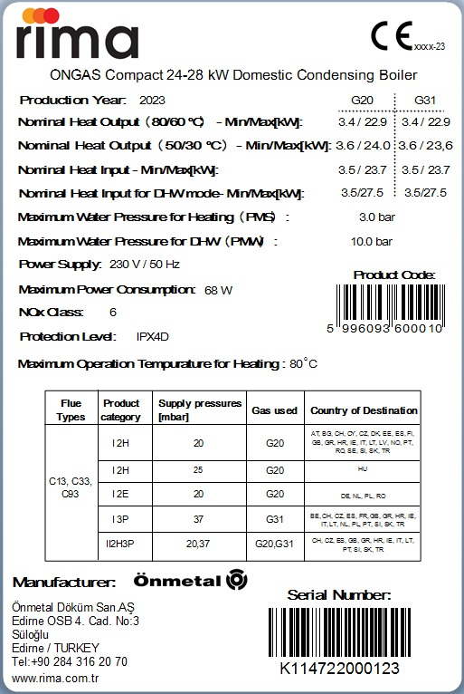

**2. GENERAL SPECIFICATIONS OF THE CONDENSING BOILER**

**2.1 General View of Components of the ONGAS Compact 24-28 kW Domestic Condensing Boiler**

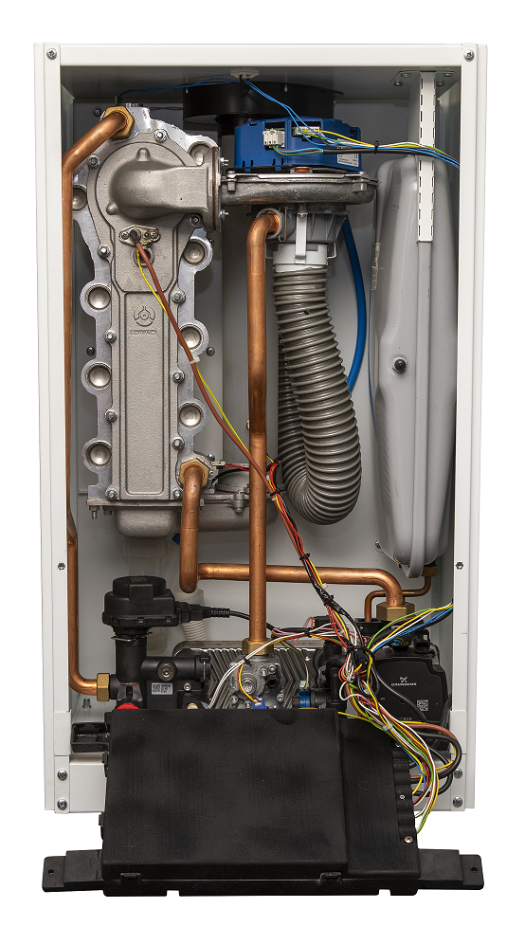

**2.2 Technical Specifications of the Boiler**

***Technical Table***

**C:\Users\Murat Oktay\Desktop\ONGAS Compact\CE Certification\tablo-1.tif**

***Water Heating Energy Efficiency***

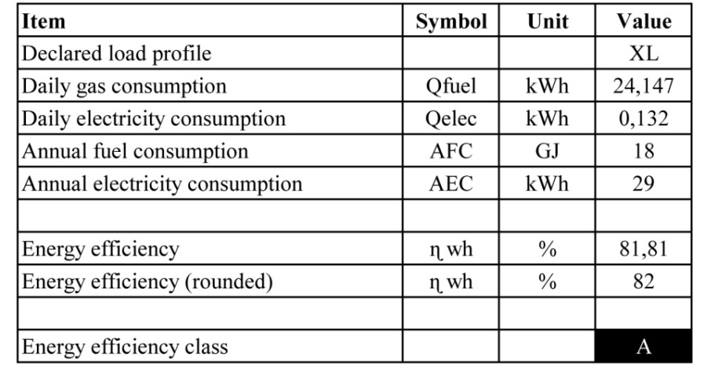

***Product Fiche***

***C:\Users\Murat Oktay\Desktop\ONGAS Compact\CE Certification\tablo-2.tif***

***Product Information***

***C:\Users\Murat Oktay\Desktop\ONGAS Compact\CE Certification\tablo-3.tif***

***Energy Label***

**C:\Users\Murat Oktay\Desktop\ONGAS Compact\Broşür çalışmaları\Kombi enerji etiketi.tif**



**3.1 Packaging and Handling**

ONGAS Compact 24-28 kW condensing boilers are dispatched as covered with sheets coated with powder-static paint, wrapped with stretch film, on pallets and inside crates. Appropriate markings are provided on the case. During storage, it may be stored at proper ambient humidity and temperature without opening the package.

ONGAS Compact 24-28 kW condensing boilers shall be placed as follows;

• Place the boiler to the boiler room taking the minimum recommended distances into account.

• Remove the gelatin, tapes, pallets and any other packaging.

• All gas appliances shall be installed by authorized persons as required by law. Any error in the installation of these devices may cause loss of life and property.

• Boilers shall be installed in a place with no risk of frost. When the boiler is not operated, the water remaining in the radiators shall be drained to prevent freezing.

• Boilers shall not be installed in a location that contains moisture, vapor or dust. Otherwise the boiler shall not operate correctly and efficiently.

• The supply of fresh air shall be free of halogen hydrocarbons (sprays, paints and some chemicals), otherwise these shall cause corrosion and erosion of the boiler and flue.

• Fresh air intake shall comply with the instructions of the local gas supplier and the instructions for gas connection, otherwise there is a risk of poisoning.

**3.2 Dimensions of the Boiler**

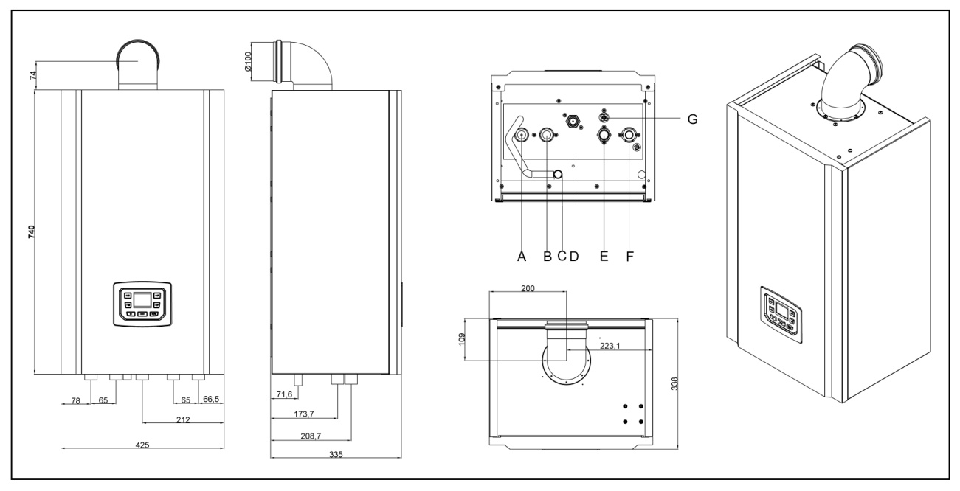

Dimensions in “mm”

|  |  |
| --- | --- |
| **Inlet&Outlets** | |
| A | Heating Outlet |
| B | DHW Outlet |
| C | Siphon Outlet |
| D | Gas Inlet |
| E | DHW Inlet |
| F | Heating Inlet |
| G | Water Filling (manual) |

**3.3 Gas Connections**

* Gas connections shall be performed by authorized personnel or by installation companies with certification for gas installations.
* Sediments and collected particles in old installations, radiators or gas pipes shall be removed before installation.
* The gas connections shall be inspected for leakage before commissioning.
* The risk of poisoning or explosion due to the operation and installation of unsuitable gas installations may result from non-compliance to rules.
* A flameproof gas valve shall be used, otherwise there is a risk of explosion in case of fire.
* Gas connections shall be made in accordance with the standards and directives.
* It is necessary to check, whether the state of adjustment given on the data plate or on the additional data plate are compatible with the local supply conditions.

Perform the gas leak test while the gas control valve is TURNED OFF. Gas valves may be subjected to a max. pressure of 150 mbar. When this pressure is exceeded, gas valves and burners may be damaged, and this result in explosions and poisoning. During the pressure test of the gas compartment, the valve at the inlet of the device shall be turned off. Please note the type of gas used in the boiler and the instructions for transformation.

Only the original RIMA spare parts and spare parts provided by the authorized local gas representative shall be used in the flue gas outlet connections. Please read the instructions before connecting the flue.

Local gas distributors may have different directives, so obtain information from your local gas companies or their representatives.

**3.4 Electrical Connections**

* Electrical connections shall be performed by authorized technicians
* The junction box, fuse, switches and sensors delivered are fully assembled and their functionality is tested.
* The main supply line and other auxiliary equipment (circulation pump, etc.) shall be connected by a qualified technician.
* Please inspect the electrical wiring diagram thoroughly before making any connections.
* Disconnect the main power line before any application. The fact that the On/Off switch is in the Off position does not necessarily mean that the power supply line is off.
* There is voltage at the boiler supply terminals even if the on/off switch is turned off.
* When connecting the boiler to the mains, a V-automat of 230V-6A with a minimum contact distance of at least 3 mm from the multi-pole switch shall be available and it shall certainly be fixed.
* The sensors shall be connected to the 24V terminals in accordance with the electrical diagrams provided.
* Electrical supply of the boiler is provided from the mains. Mains supplied electrical equipment is obligated to connect earth.

**Connection Terminals**

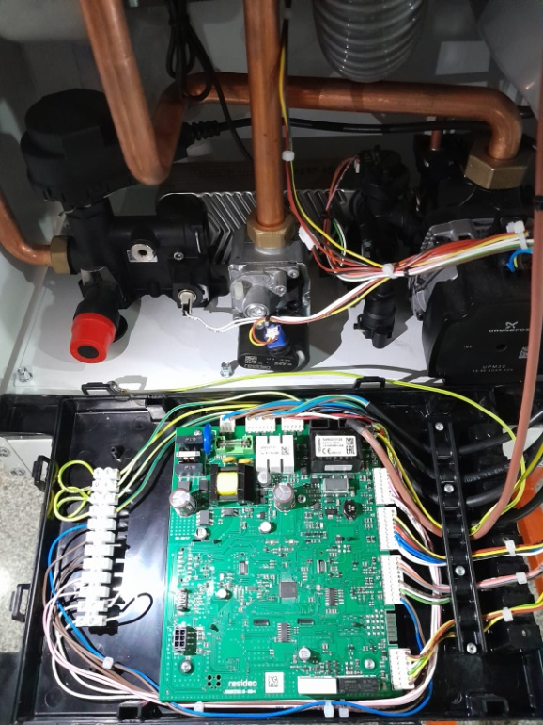

* During the commissioning, the boiler control performs an internal inspection for about 10 seconds
* The electrical values of the connected controls shall be suitable for the loads activated by the boiler control (e.g. controller, SDC, room thermostats…)
* The device shall be commissioned by RIMA authorized services. Disconnect the power supply to prevent electrical shock or equipment damage.
* The device is connected to the power network through a fixed connection. The electrical connection shall be permanently connected through a disconnecting device (cut-off switch, fuse) with a contact distance of at least 3 mm. Connection cable (flexible, 3x1.0 mm2 max. 3x1.5 mm2 TTR)

**3.5 Ongas Compact 24-28 kW Electrical Wiring Diagram**

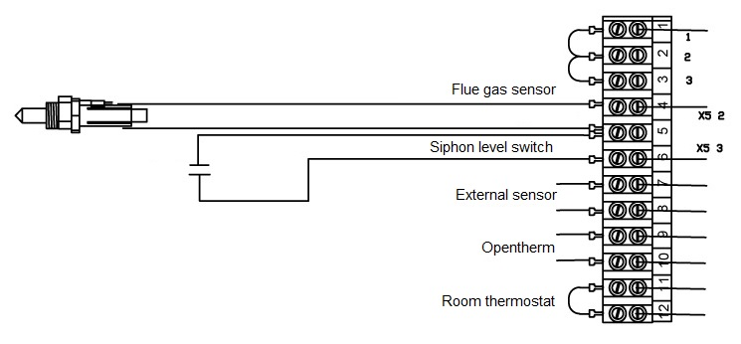

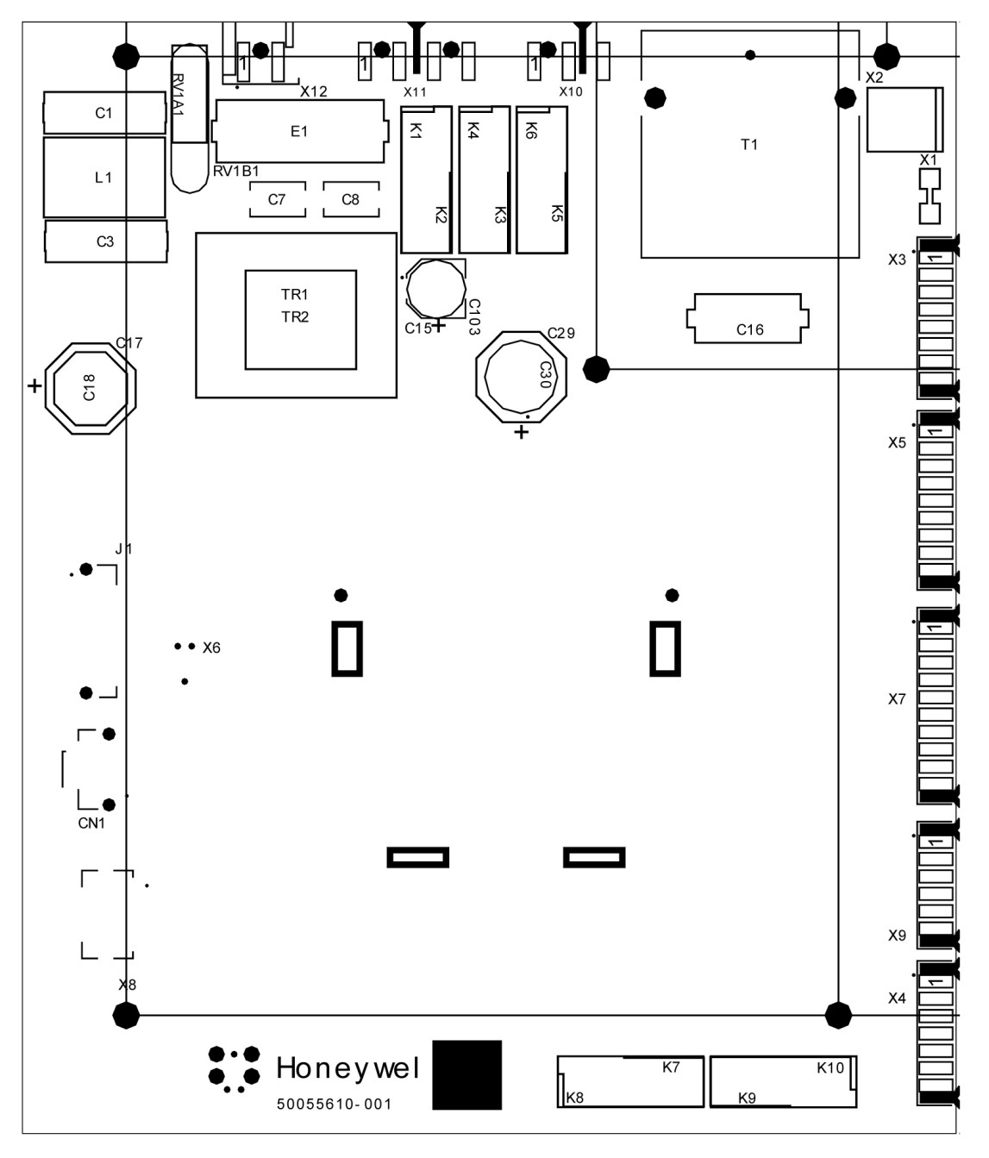

**3.6 Starting up and closing the boiler**

The following instructions shall be followed to operate the unit.

* Fill the boiler in with fresh water and make sure that there is pressure inside (at least 0,8 bar)
* Open the main gas supply to boiler
* Plug-in the main supply of the boiler
* Switch on the boiler by pressing Stand-by Button, (3) pushbutton indicated below
* Air purge function will be started automatically. In this function fan will start with maximum number of revolutions. Also in the same time, supply pump will be switched on for 5 seconds and off for others 5 seconds continuously. Check the fan and pump is running properly.
* Apply the gas rate adjustment within the test mode

To close the boiler use the same way by reversing the actions above. Push the button (3), plug-out the main supply and close the gas.

**4.1. Control Panel Display**

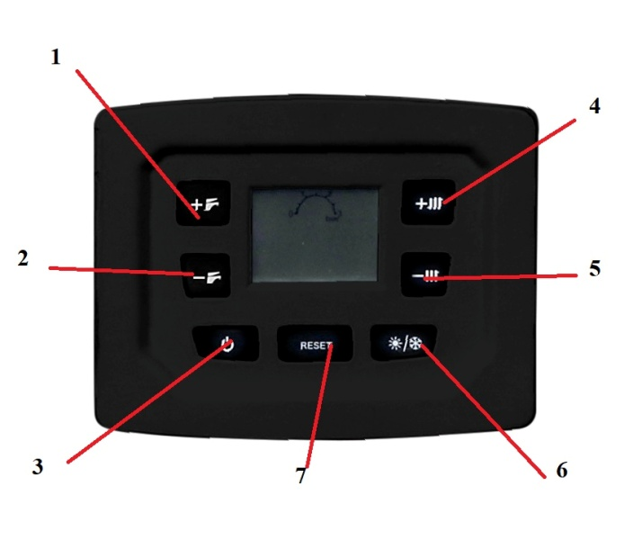

1- Domestic water temperature increase button

2- Domestic water temperature decrease button

3- “Stand-by” button, Press the button once to put the device in operation

4- Heating circuit temperature increase button

5- Heating circuit temperature decrease button

6- Operating mode selection button, mode can be changed to winter mode or summer mode by pressing once

7- Reset button, in case of permanent error, it is pressed once after the problem is solved and the device is removed from the error state

**4.2 Modes of Operation**

The controller has a number of operation modes:

* OFF mode, heat demands are ignored except for CH and DHW frost protection calling
* STAND-BY
* CH mode
* DHW mode
* TEST or INSTALLER MODE, option for the installer to test and set boiler parameters
* ERROR/FAULT conditions like high temperature, lockout, sensor fault, etc.

The priority of operating modes is fixed as follows:

1. Error/fault mode

2. Test or Installer mode

3. DHW mode

4. CH mode

5. Stand-by mode

6. OFF mode

In case of normal operation in DHW or CH mode and no error conditions it is always possible to enter the test mode as the higher priority mode of operation. This implies that there are no error conditions present. If there was an error condition, test mode can be entered after normal operating conditions are present again.

**4.2.1 OFF Mode**

This is mode is selected by mean of the (3) pushbutton. When selected, LCD is indicating:

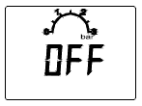

**4.2.2 STAND-BY Mode**

By mean of (6) pushbutton it possible to select boiler STAND-BY modes selecting Winter (both DHW and CH modes are enable) or Summer (only DHW mode is enable) working conditions. When Winter is selected, an no head demand is present, LCD is indicating:

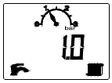

When Summer is selected, an no head demand is present, LCD is indicating:

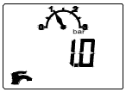

In STAND-BY mode the fan is off, the gas valve is closed, Supply pump is switched off and the 3WV is in 3Way valve standby position.

**4.2.3 Setting CH Supply Temperature**

Operate (5) (decrease) and (4) (increase) pushbuttons to select CH supply temperature within 20°C and CH user set point maximum value. This value is called CH user set point. When (5) or (4) pushbuttons are operated, the LCD displays the temperature setting in 1°C steps in flashing mode:

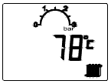

5 sec. since last acting on (5) or (4) pushbuttons has been made, LCD come back to the previous display condition.

**4.2.4 Setting DHW Supply Temperature**

Operate (2) (decrease) and (1) (increase) pushbuttons to select DHW temperature within 30°C and DHW user set point maximum value. This value is called DHW user set point. When (2) or (1) pushbuttons are operated, the LCD displays the temperature setting in 1°C steps in flashing mode:

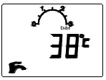

5 sec. since last acting on (2) or (1) pushbuttons has been made, LCD come back to the previous display condition.

**4.2.5 Burner ignition**

In case of valid heat demand request, ignition sequence will be started. In case of failed ignition, controller will try to re-ignite for a defined number of times. At the first ignition trial, the burner will ignite with fan speed set by Ignition fan speed value. As soon as the flame presence is validated, fan speed moves according to the heat demand type. If no successful ignition after programmed number of retrials, flame lockout error will be indicated.

**4.2.6 CH Mode**

Operation in the CH mode is possible only when Winter is enabled. Supply pump is switched on.

Burner start and stop condition are:

Burner start: Supply sensor < CH user set point - CH hysteresis ON

Burner stop: Supply sensor > CH user set point + CH hysteresis OFF

Once the starting sequence is over, continuous flame modulation begins by regulating the speed of the fan. The fan speed is regulated between CH minimum fan speed and CH maximum fan speed settings.

Continuous flame modulation uses a PI algorithm to reset the error between the temperature read by the supply sensor and the CH user set point.

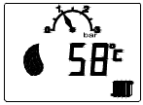

During a CH heat demand, if the burner stops because of burner stop condition occur, burner itself may be reignited only once the CH OFF time is elapsed. The timer starts immediately after the burner is switched off.

Following a CH heat demand, after the start-up sequence (flame presence validated by the controller), the speed of the fan stays at CH minimum fan speed for a time defined by CH minimum time parameter.

Then fan speed starts to ramp to its set point with a programmable slope (CH slope rate in °C/min); this time means that supply temperature set point is increased with CH slope rate °C per minute.

At the end of a CH heat demand, the Supply pump continues to be supplied for a time equal to the CH pump overrun timer.

CH frost protection is enabled in all the specified operating modes. The temperature read by the Supply sensor is continuously monitored; when it drops below the CH frost protection ON value, a CH heat demand is generated. Supply pump is switched on.

Burner start and stop condition are:

Burner start: Supply sensor < CH frost protection ON

Burner stop: Supply sensor > CH frost protection OFF

CH frost protection function is performed with fan speed set to the CH minimum fan speed.

**4.2.7 DHW Mode**

Our configuration in DHW mode is Instantaneous: Combi boiler with Instantaneous DHW heat exchanger, electric diverting 3WV, DHW flow switch, DHW sensor (instantaneous temperature sensor placed on the DHW heat exchanger outlet).

Operation in the DHW mode is possible only when Winter or Summer are enabled. DHW heat demand is generated by a closure of the reed contact of the DHW flow switch. Supply pump is switched on.

Burner start and stop condition are:

Burner start: DHW sensor < DHW user set point + DHW hysteresis ON

Burner stop: DHW sensor > DHW user set point + DHW hysteresis OFF

Once the starting sequence is over, continuous flame modulation begins by regulating the speed of the fan. The fan speed is regulated between DHW minimum fan speed and DHW maximum fan speed settings. Continuous flame modulation uses a PI algorithm to reset the error between the temperature read by the DHW instantaneous sensor and the DHW user set point.

During a DHW heat demand, the temperature value read by the supply sensor is continuously monitored.

Burner is switched OFF and subsequently ON, when the following conditions occur:

Burner stop: Supply sensor > CH limit set point – HIGH

Burner start: Supply sensor < CH limit set point – LOW

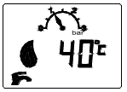

At the end of a DHW or DHW frost protection heat demand, the Supply pump continues to be supplied for a time equal to the DHW pump overrun time.

DHW frost protection function: Temperature read by the DHW sensor is constantly monitored; when it drops below the DHW frost protection ON value, a DHW heat demand is generated (according to the DHW configuration setting). Supply pump is switched on.

Burner start and stop condition are:

Burner start: DHW sensor < DHW frost protection ON

Burner stop: DHW sensor > DHW frost protection OFF

DHW frost protection function is performed with fan speed set to the DHW minimum fan speed.

**4.3 Protection and Error Conditions**

Several checks are included to protect the boiler and its environment. Severe error will cause a lockout condition which can only be cleared by the (7) (RESET) pushbutton, locally. Non severe errors faults will reset as soon as the cause of the problem disappears.

In case of lockout and blocking conditions, fan will not operate; Supply pump over run will be executed (if Supply pump was running when lockout or blocking condition occurred).

The supply pump will also run in case of:

* CH frost protection
* DHW frost protection
* CH thermostatic pump overrun
* Supply pump anti-sticking function

These exceptions are not valid in case of Water pressure errors and water fill. The solar pump is switched off in case of any error. If all the attempts are wasted, volatile lockout error code F13 + S7 icon (SERVICE) are displayed on the LCD (alternating F13 with error code Exx or Fxx which has been trying to reset). It is possible to reset this limitation by removing the power supply from the board.

In this way, other 5 reset per hour can be done.

Error codes can be divided in 2 groups:

1. Lockout condition codes

2. Blocking condition codes

**4.3.1 Lockout condition**

Lockout condition is given with the capital "E" (error) on the status display and error code on the temperature display:

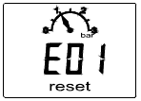

Lockout condition needs to be solved by Service people or pushing (7) pushbutton (RESET). The meaning of the error numbers are as follow:

E01 Ignition Lockout indication

E02 False flame indication

E03 High limit temperature protection (supply or return sensor)

E05 No frequency feedback from fan after 1 minute

E08 Flame circuit failure

E09 Valve feedback error

E12 EEPROM integrity lockout

E15 Drift sensors check failed

E16 Supply sensor stuck_at test failed

E17 Return sensor stuck_at test failed

E18 Cracked sensor test failed

E21 Adc failure

E33 Return water temperature sensor error

E35 Supply water temperature sensor error

E01 = Lockout signal after no flame and all ignition trials are expired. this error condition is stopping the boiler and to get to the normal operation again, manual/remote reset is required.

E02 = If flame signal is measured with no heat demand currently present, error 2 is created. This error condition is stopping the boiler and to get to the normal operation again, manual/remote reset is required.

E03 = High limit temperature protection detected on supply or return sensor. This error condition is stopping the boiler and to get to the normal operation again, manual/remote reset is required.

E05 = Fan driving problem – if the controller doesn’t detect the expected tacho signal from the fan for 1 minute longer, error will be set. This error condition is stopping the boiler and to get to the normal operation again, manual/remote reset is required.

E08 = Flame circuit failure – The detected flame level is outside expected bounds, meaning a problem on electronic components.

E09 = Feedback error – The valve feedback doesn’t respect controller commands.

E12 = The EEPROM check fails. The data in EEPROM are corrupted.

E15 = Drift sensors check failed. Manual/remote reset is required.

E16 = Stuck_at test on Supply sensor failed. Manual/remote reset is required.

E17 = Stuck_at test on Return sensor failed. Manual/remote reset is required.

E18 = Crack sensor test failed. Manual/remote reset is required.

E21 = Adc failure. The adc test executed at runtime fail, that detect a major fault on electronic components.

E33 = Return sensor out of normal operating range (short circuit or open circuit). If NTC sensor goes outdoor the range (00÷125°C), error will be generated. In case sensor is back to the normal operating range, lockout can be cleared by manual/remote reset. In error mode, heat demands will be disabled. In case 2 or more sensors are broken, controller will pick up the first that was outside the operating range. Resolving situation can be achieved only if the sensor is within operating range again. The lockout error on this sensor is necessary because is it used for high limit protection.

E35 = Supply sensor out of normal operating range (short circuit or open circuit). If NTC sensor goes outdoor the range (00÷125°C), error will be generated. In case sensor is back to the normal operating range, lockout can be cleared by manual/remote reset. In error mode, heat demands will be disabled. In case 2 or more sensors are broken, controller will pick up the first that was outside the operating range. Resolving situation can be achieved only if the sensor is within operating range again. The lockout error on this sensor is necessary because is it used for high limit protection.

**4.3.2 Blocking condition**

Temporary blocking condition is given with the capital "F" on the status display and error code on the temperature display:

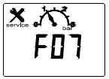

The boiler controller recognizes also the fault situations that can block the heat demands but do not lead to lockout condition. When the error condition becomes resolved, error will disappear but will be also written into the history data. Lockout condition needs to be solved by Service people. The meaning of the error numbers are as follow:

F07 Exhaust gases temperature is too high

F13 Remote reset volatile lockout

F34 Low power supply from mains

F37 Water pressure is too low (blocking code is shown alternatively with WP value if WPS is used)

F39 Outdoor sensor error

F40 The water pressure in the CH installation is too high

F41 Water filling (auto) is running

F42 Water filling (auto) not completed

F43 Low water pressure after auto water filling attempts

F47 Water pressure sensor not connected

F50 DHW solar storage tank BOTTOM sensor error (only when DHW configuration is 2 or 4)

F51 PT1000 temperature sensor error (only when DHW configuration is 2 or 4)

F52 DHW water temperature sensor error

F53 Exhaust gases temperature sensor error

F81 Drift test waiting

F07 = If the exhaust gases temperature becomes higher than Maximum exhaust gases temperature controller will stop indicating F07. The blocking timer of 15 minutes is set. If the exhaust temperature is within normal levels after this time expired, F07 will be resolved by itself. Error can be reset by switching off and on the power supply if the temperature is back in range.

F13 = All the attempts to reset the error remotely, either from OT unit or by button, are wasted. It is a volatile lockout which disappears after removing supply.

F34 = Low Mains voltage (less than 170VAC) will trigger this error. In case of boiler running, burner is switched off. When mains brought back (over 170VAC), error is resolved.

F37 = Low water pressure error can be caused by the low water pressure (water pressure lower than Water pressure low limit or water pressure switch contact opens). In error mode, the heat demand and the supply pump are switched off. Heat demands are ignored. Diverting 3WV is moved in CH position (if it is not already there). Error is self resolved when water pressure value comes back over the Water pressure nominal or water pressure switch contact is being closed.

F39 = Outdoor sensor out of normal operating range (short circuit or open circuit). If NTC sensor goes in short circuit and this condition lasts for more than 3 seconds, error is generated. In case sensor is back to the normal operating range, error is gone. Normal operating range for the outdoor sensor is from -40°C till +50°C. With sensor broken in a way that he makes an open circuit, error will be generated only if a curve is selected: OTC will be disabled but heating mode will be possible. In case 2 or more sensors are broken, controller will pick up the first that was outside the operating range. Resolving error situation can be achieved only if the sensor is within operating range again.

F40 = High water pressure error, caused by the water pressure sensor. Water pressure is higher than Water pressure high limit. In error mode, the heat demand and the pumps are switched off.

F47 = Water pressure sensor not connected. In error mode, the heat demand and the pumps are switched off. Resolving error situation can be achieved only if the sensor is connected again.

F50 = DHW sensor out of normal operating range (short circuit or open circuit). If NTC sensor goes outside the range (-5÷125°C), error will be generated. In case sensor is back to the normal operating range, error is gone. In error mode, heat demands will be disabled. In case 2 or more sensors are broken, controller will pick up the first that was outside the operating range. Resolving situation can be achieved only if the sensor is within operating range again.

F51 = Solar panel sensor (PT1000) out of normal operating range (short circuit or open circuit). If NTC sensor goes outside the range (-20÷150°C), error will be generated. In case sensor is back to the normal operating range, error is gone. In error mode, heat demands are not disabled. In case 2 or more sensors are broken, controller will pick up the first that was outside the operating range. Resolving situation can be achieved only if the sensor is within operating range again.

F52 = DHW sensor out of normal operating range (short circuit or open circuit). If NTC sensor goes outside the range (-5÷125°C), error will be generated. In case sensor is back to the normal operating range, error is gone. In error mode, heat demands will be disabled. In case 2 or more sensors are broken, controller will pick up the first that was outside the operating range. Resolving situation can be achieved only if the sensor is within operating range again.

F53 = Exhaust sensor out of normal operating range (short circuit or open circuit). If NTC sensor goes outside the range (-5÷125°C) and this condition lasts for more than 3 seconds, error will be generated. In case sensor is back to the normal operating range, error is gone. In error mode, heat demands will be disabled. In case 2 or more sensors are broken, controller will pick up the first that was outside the operating range. Resolving situation can be achieved only if the sensor is within operating range again.

F81 = Drift test waiting. System is waiting for sensor drift test. A possible HD can not be satisfied (only supply pump is running).

Faults not observed Due to the boiler configurations, can happen that some faults are disabled:

1. In case of water pressure switch error F40 does not apply.

2. In case of DHW sensor not used, error F52 does not apply.

3. In case of OTC curve not selected, error F39 does not apply.

4. In case of solar function not used, error F51 and F50 does not apply.

**4.4 Room Thermostats**

The comfort of your living spaces is at your fingertips! With the Smart Thermostat, you can adjust the temperature of your home whenever you want and save up to 30% of energy.

**SMART THERMOSTAT**

At home, at work or on the way, you can easily control the temperature of your home remotely with the application on your mobile phone (Compatible with IOS and Android devices).

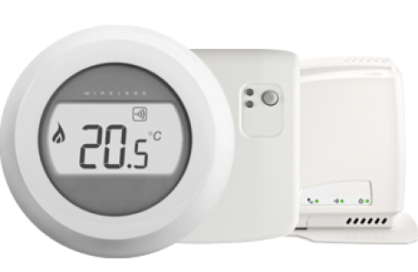

**SMART THERMOSTAT MODULATING (with OpenTherm connection)**

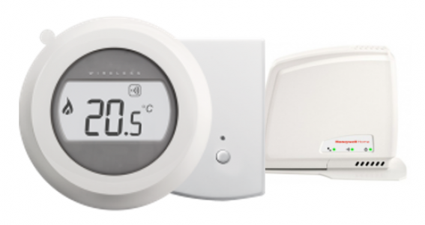

**ROOM THERMOSTAT MODULATING (Standart one)**

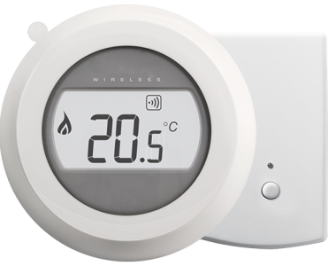

**DIGITAL ROOM THERMOSTAT (with time programming)**

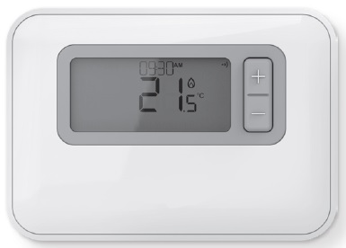

**ON/OFF ROOM THERMOSTAT**

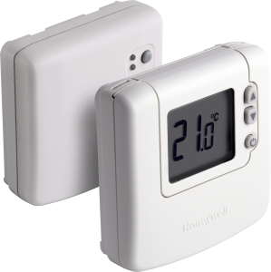

**SMART THERMOSTAT (with Modulating option) -** Compatible with IOS and Android devices

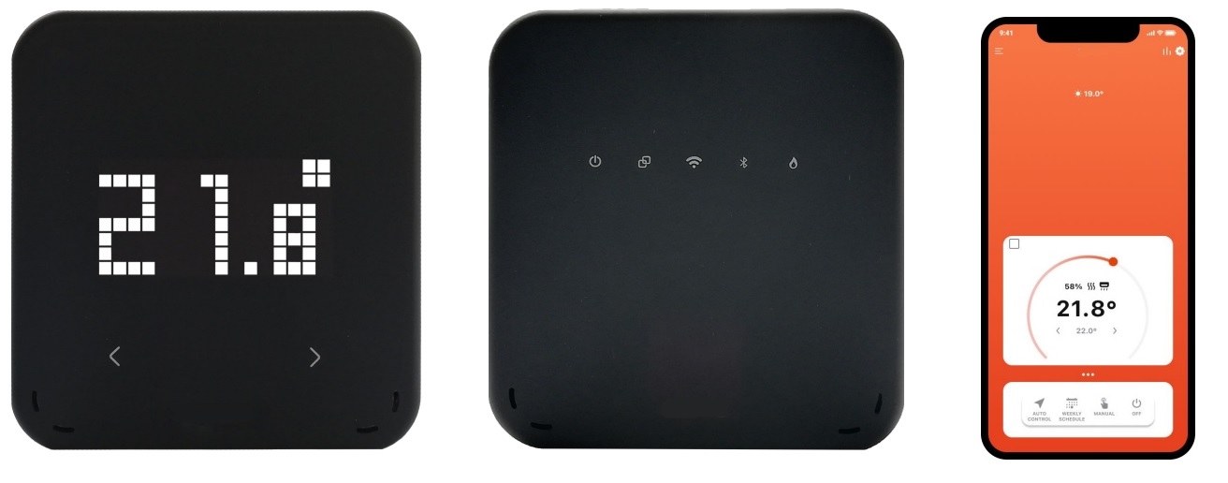

**5. INSTALLATION AND INSPECTION OF THE PIPING**

**5.1. Heating Radiator Water (Water Quality and Related Operations):**

Precautions shall be taken for hardness of water (lime that is soluble in water) and for particles that form sediments.

**Hardness:** Lime, which is soluble in water, settles quickly on hot surfaces when water is heated, and forms an insulating layer and prevents the transfer of heat. As a result, the fins of the heat exchanger overheat and crack at this point after a while. The water channels in the sections where condensation takes place are narrow in the fins of the boiler. Therefore, the boilers are sensitive to calcification (forming of scab).

Calcified boilers are not covered by the warranty.

To prevent calcification, water used in the installations shall be softened. While there are various methods for this purpose, the most applicable one is to install a resin softening system to the installation.

In addition, authorized services shall measure the hardness value of the installation water while commissioning the boiler and condition the water by adding a “chemical additive” in accordance with this hardness value. The chemical protective additive sample for delaying the calcification is sent free of charge by the manufacturer in the packaging of the boiler. Then, in case of addition of fresh water to installation water; the chemical additive shall be requested from the manufacturer for a fee.

(If water level in the installation is reduced, fresh water to be added to the installation shall be supplied together with chemical additives. Chemical additive is sold in our dealers in 5-liter packages.)

**Sediment:** Particles that cause sediment in the water piping accumulate on the heat transfer surfaces in the form of a sludge layer where the flow of water slows down, thus preventing circulation of water and slowing the heat transfer.

A sediment trap shall be used instead of sieve and cartridge type filters, to remove materials that cause sediment. Water cannot pass through these filters when the surfaces of the sieve/cartridge type filters are filled with sediment in the water, and this causes the boiler to operate without water, overheat and thus causes calcification. In sediment traps, however, the sediment settles in the form of sludge and water continues to pass from the top. The sediment traps are required to be cleaned periodically; but cleaning periods are much longer than sieve/cartridge type filters.

Instructions have been issued by various organizations on the quality of the water used in the heating and boiler systems; e.g. VDI Directive 2035, DIN EN 14868 Standard of German Norm Institute, Data Sheets VdTUV 1453 and 1466, Commission for Steam Boilers TRD611…

According to these instructions, the following reference values ​​apply to prevent excessive build-up of lime (calcium carbonate) in heating systems with operating temperatures up to 100°C;

VDI Directive 2035 “Prevention of damage to hot water heating systems - formation of boiler stones in domestic water and hot water heating systems” (also refer to the original text of the regulation):



In cases where these conditions are not met, the filling and additional water of the boilers shall be softened. The cost of water treatment is in any case less than the cost of the repairing of the damages in the boiler system. Damages caused by corrosion and calcification are not covered by the warranty.

**Transformation of the old heating installation:** In such installations, sediments and residues from old boilers, radiators and pipes may be filled into the boiler, causing clogging of the boiler or very low flow rate of water. This causes the temperature of the boiler heat exchanger to increase and consequently causes cracks on the fins. Thus, if the boilers shall be used in the old heating installation, the installation shall be washed very well; and we strongly recommend the use of a plate heat exchanger instead of the balance vessel between the boiler and the installation.

**5.2. Condensation Water Drain**

* Condensation water which is generated during to the combustion, transfers to the water drains connection by the siphon and drain hose.
* Condensate water outlet shall not be modified or blocked.
* Condensation water is acidic and corrosive (approx. 2 ph). So all of the connections which are made for condensation water must be made with PP type pipes.
* Condensation water must be transferred to the drain with the shortest way possible.
* For health and environmental reasons it mustn’t transfer such places near people, animals and plants. Condensation water must not be connected to rain drain systems.
* The condensate drain line must have a slope of at least 3%.
* A neutralization tank should be used for condensate water occurring in systems with a total power of 200 kW and above.
* It is mandatory to comply with the relevant local regulations for the discharge of condensate water.

**5.3 Instructions for the Adjustment of Gas Ratio**



A fire or explosion hazard may cause damage, serious injuries, or death.

**5.3.1 Gas Leak Test**

* The gas leak test shall only be carried out by an authorized service or an expert.
* Test all pipe connections in the flow path of the gas control unit with a rich mixture of soap and water. The formation of bubbles indicates the presence of a gas leak.
* If you observe a gas leak, tighten the pipe fitting.
* Stand in a safe place to prevent injury from gas leaks, which could cause a flare back at the inlet of the unit when the main burner is ignited. Ignite the main burner.
* While the main burner is operated, test all pipe joints (including adapters), and inlets and outlets of the gas control unit with a rich mixture of soap and water.
* If you observe another gas leak, tighten the adapter bolts, pipe joints and connections.
* If it is not possible to stop the gas leak, replace the part.

Perform gas leak inspections on the gas control unit at any time during operation. Keep the mixture of soap and water soap away from electrical connections. Disconnect the main line to prevent electrical shocks and damage to the equipment damage. Wiring shall comply with local regulations. Always follow the instructions of the manufacturer of the unit. Check if the type number is correct for the application before installation or replacement. Make sure that there is no gas left in the combustion chamber before starting the boiler. When the installation is complete, perform a final inspection. The boiler may be locked during the commissioning; press the reset button. Under normal circumstances, service or maintenance shall not be required.

**5.3.2 Adjustment of the Gas Ratio**

Adjustments of gas ratio shall be performed separately at full modulation speed (100%) and at the minimum modulation speed (0%) of the boiler. The boiler shall be set to test mode for the adjustment of modulation.

***Test Mode:***

Test mode is enabled by pressing (4) and (5) pushbuttons together for 5 seconds. In this mode the boiler operates as in CH mode, however there is no modulation. When this function is selected the boiler starts working in CH mode with fan speed set to the CH maximum fan speed parameter.

The SERVICE symbol is displayed on the LCD when Test mode is active.

Test mode can be used as a sweeper function. The fan speed can be set:

- by (1) and (2) pushbutton (steps of 50 rpm) between the range CH maximum fan speed and CH minimum fan speed

- by (4) (CH maximum fan speed)

- by (5) (CH minimum fan speed)

At this time, the flue gas analyzer is prepared for measurement and the measuring probe is inserted into the flue through the gas measuring hole. Gas valve adjustment process performed with the appropriate tool is continued until the emission values provided in the table below are reached;

|  |  |  |
| --- | --- | --- |
| CO2 ratio (%) | G20 | G31 |
| Min. | 9,1 | 9,5 |
| Max. | 9,5 | 10,4 |

Adjust the ratio of gas by checking the emission values (O2, CO2, CO) received from the flue gas analyzer as per the technical specifications table. Decrease the value of CO2 by rotating the adjustment section to the right, and increase the value of CO2 by rotating it to the left using a proper allen wrench set (as shown in the figure). Resume this process until the emission values ​​provided in the technical table are reached.

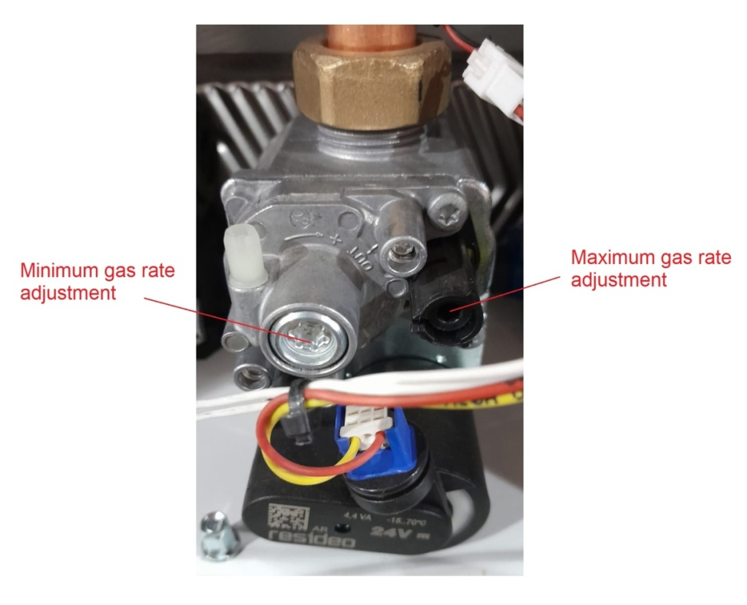

***Conversion from natural gas to LPG operation***

There is no need to change anything mechanical on the boiler (from the gas valve etc.). Only gas rate adjustment must be done within above limits and with above actions. During the conversion from one gas to another, adjustments and modifications shall only be carried out by a qualified professional or competent person; when an adjustment is carried out, the adjuster shall be sealed after the adjustment.

**5.4 Flue Connections**

The boiler is designed for the C11, C33 and C93 flue configurations:

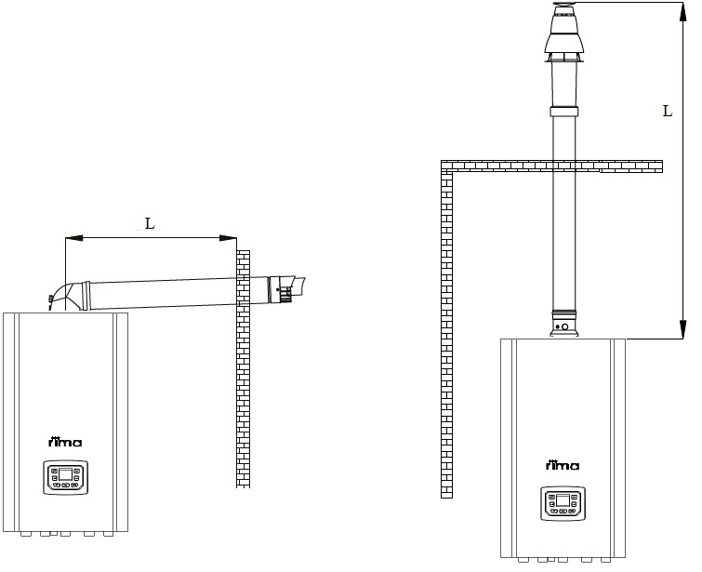

Coaxial chimney types:

Ø60/100 maximum distance of L horizontal: 10 meters

Ø60/100 maximum distance of L vertical: 10 meters

**6. CLEANING, MAINTENANCE AND REPLACEMENT OF THE BODY**

Periodical maintenances of the boiler shall be performed regularly. Otherwise this shall cause a decrease in the efficiency of the boiler and an increase in the fuel consumption.

Maintenance or repairing operations shall not be carried by the end user, he/she may only clean the room and clean the exterior of the unit with a damp (i.e., not wet) cloth. Any other issues are described in the maintenance and repairing section below, which shall be carried by only qualified person which is authorized by Rima company.

* Periodical and annual maintenances of the boiler shall be performed regularly.
* Original spare parts recommended and provided by RIMA shall always be used for maintenance and repair operations.
* The power shall be disconnected from the mains switch for maintenance and cleaning operations.
* Disconnect the main line, turn off the main gas valve and allow the boiler to cool before starting to work on the boiler.

Consider the following issues during the annual inspection of the boilers:

* inspection and cleaning of the boiler’s combustion system (fan, venturi and burner)
* inspection and cleaning of the electrodes
* inspection of leaks (water, gas and flue gas)
* inspection of water pressure
* inspection and cleaning of siphon
* chemical/or mechanical cleaning of heat exchanger

During the annual use of the boilers, particulate contamination may occur on the fresh air suction line, on the surface of the fins and on the condensate container and siphon as a result of combustion of the gas. Moreover, parts such as the return filter shall be inspected at least once (1) a year and shall only be cleaned by the authorized service.

**6.1 Inspection of the Combustion System**

It shall be inspected by operations such as the measurement of the O2/CO2 ratio from the measurement test point at the flue gas outlet with an analyzer. The boiler shall be operated at a temperature of about 70°C for this purpose. The measurements shall match the values for the gas ratio adjustment. And the flue gas temperature may be measured at the test nipple measuring point in the flue. If the flue gas temperature exceeds the return water temperature by more than 30°C, this may indicate that the heat exchanger is contaminated. It shall always be inspected and cleaned properly.

**6.2 Cleaning of the Modulated Fan, Venturi and the Burner, and the Electrodes**

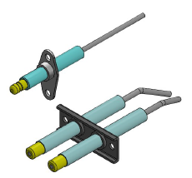Remove the electrical connections from the fan, gas valve and the electrodes.

1. Remove the bolts on the exterior of the burner.

2. Clean the Premix burner with an air gun (the distance between the nozzle and burner shall be about 1 cm and the pressure of the compressed air shall be 2 – 4 bar).

3. Remove the dusts on the fan and the burner.

4. Clean the venturi pipe with a plastic brush and air.

5.Install all parts you have removed again; check the position of the gasket plate between the fan and venturi is correct.

**6.3 Cleaning of the Siphon**

It shall be disassembled, the sediment collected inside shall be cleaned and then it shall be reassembled; and this process shall be made into a routine.

**7. WARRANTY AND COMMISSIONING**

**Warranty Conditions**

**1)** Warranty period starts with the delivery date of the goods. **Warranty period for condensing boilers is two (2) years.**

**2)** The goods are under warranty cover as a whole including all of their parts.

**3)** In the event that the goods are found to be defective, the consumer shall have the right to ask for the implementation of one of his/her rights specified in Article 11 of the Law No. 6502 on Consumer Protection: **a) Returning from the contract, b) Requesting a discount from the sales price, c) Requesting free repair, d) Requesting the replacement of the sold goods with an undamaged equivalent.**

**4)** If the consumer chooses **the right for free repair amongst these rights**, the seller is obliged to repair or have the product repaired without charging any fee under the name of labor cost, replacement part cost or any other name. The consumer may also exercise the right for free repair against the manufacturer or importer, too. The seller, manufacturer and importer are jointly responsible for exercising of this right by the consumer.

**5)** If the consumer uses the **right to repair free of charge**, the consumer may request **the return of price of the goods, price reduction at the ratio of the defect or the replacement of the goods with an equivalent free of defect** from the seller in the following cases;

- Repeated failure of the goods within the warranty period,

 - Exceeding of the maximum time allowed for repair,

- In the event that repair is not possible is determined by the authorized service station, seller, manufacturer or importer with a report. The seller is not allowed to reject the request of the consumer. The seller, the manufacturer and the importer are jointly liable if this request is not fulfilled

6) The repair period of the goods shall not exceed 20 working days. This period starts from the date of notification of the failure of the goods to the authorized service station or the seller if it is within the warranty period, and starts from the date of delivery of the goods to the authorized service station if the warranty period has expired. If the failure cannot be repaired within 10 working days, the manufacturer or importer shall allocate another good with similar characteristics to the use of the consumer until the repair of the goods is completed. If the goods fail within the warranty period, the period spent in repair shall be added to the warranty period.

7) Failures resulting from the use of the goods contrary to the points stated in the instruction manual are not covered by the warranty.

8) The consumer may apply to the **Consumer Arbitration Committee** **or the Consumer Court** of his/her residence or at the jurisdiction of the place where the consumer transaction is performed in case of any disputes regarding the exercise of the rights arising from the warranty.

9) If this **Warranty Certificate** is not provided by the seller, the consumer may apply to the **General Directorate of Consumer Protection and Market Surveillance of the Ministry of Customs and Trade**.

The minimum service life specified by the Ministry of Customs and Trade for these devices is 10 years. During this period, the manufacturer and seller companies undertake to service the device and to provide spare parts.

**When the boilers are commissioned by the Authorized Service, you have to sign the form below and submit it to the service, and have the “Warranty Certificate” signed by the authorized service. It is highly recommended that you follow the operating instructions provided here to ensure trouble-free operation of the boiler over long periods of time.**

Manufacturer

Önmetal Döküm San. Tic.

Edirne Org. San. Böl. 4. Cad. No:3-5 Domurcalı/ Süloğlu/ EDİRNE

Tel: 0284 316 20 40

To get information on subjects related with sales;

Rima Isı Sis. San. A.Ş.

İkitelli OSB Mah. 25. Cad. No:10 Başakşehir/İSTANBUL

Tel: 0212 485 48 74

To get information on after-sales services;

Rima Isı Sis. San. A.Ş.

İkitelli OSB Mah. 25. Cad. No:10 Başakşehir/İSTANBUL

Tel: 0212 485 48 74



All rights are reserved. Rima reserves the right to make changes on all their products without giving prior information.

Rev01